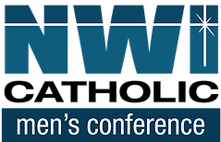

Northwest Indiana Catholic Men's Conference
Source and Summit
St. Patrick Catholic Church, Chesterton, IN
Saturday, October 2022
8:00 a.m. – 3:00 p.m.

“If Anyone Eats of This Bread He Will Live Forever”
JOHN 6:51
Come and listen to a dynamic team of speakers, encounter the living presence of Jesus Christ in word and sacrament, learn and grow as a disciple of the Lord, and meet and worship the Lord with other men of faith!

Featured speakers include:
- Father Leo Patalinghug
- Deacon Darrell Miller
- Jim Beckman

Featured Musician:
- Patrick Williams

This year's Conference includes:
Speakers, Music, Adoration
Confession, and Holy Mass

$35.00 Adult / $20.00 College or High School Student,
Includes a light continental breakfast and lunch

Register today online www.nwicatholicmen.com

